**Ingress troubleshoot issue for Sandbox Environment**

The endpoints in the sandbox ingress are not hitting for the below two endpoints

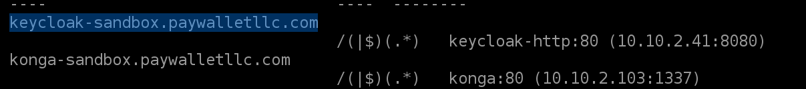

checked whether dns is mapped correctly or not, after checking the dns value and sandbox-ingress address.

Dns value I gave in godaddy is **a1e527f40c2b24be99211bff9d10adda-24a1474d7f9387d0.elb.us-east-1.amazonaws.com** because it is active Alb.



But in sandbox ingress it is mapped to **a1e527f40c2b24be99211bff9d10adda-1143282453.us-east-1.elb.amazonaws.com** which is inactive ALB.

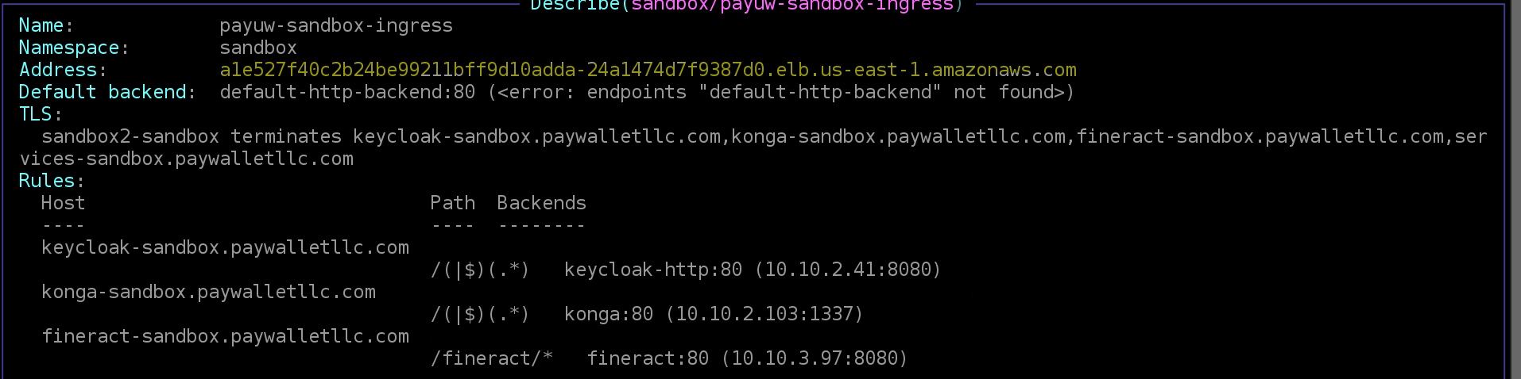

In that Address earlier there is in active Alb value I.e. **a1e527f40c2b24be99211bff9d10adda-1143282453.us-east-1.elb.amazonaws.com**

Now, I check the **hostname** in ingress controller it is also mapped to in active ALB (**a1e527f40c2b24be99211bff9d10adda-1143282453.us-east-1.elb.amazonaws.com)**



**( Note:** Upper image is showing the latest **hostname** value, at the time of issue it shown as **a1e527f40c2b24be99211bff9d10adda-1143282453.us-east-1.elb.amazonaws.com)**

after that try to edit the ingress-controller manually tried to changed the hostname**: a1e527f40c2b24be99211bff9d10adda-1143282453.us-east-1.elb.amazonaws.com** from this to **a1e527f40c2b24be99211bff9d10adda-24a1474d7f9387d0.elb.us-east-1.amazonaws.com**, even after that also there is no change in ingress address.

Now checked the ALB type in console, it is Network type,

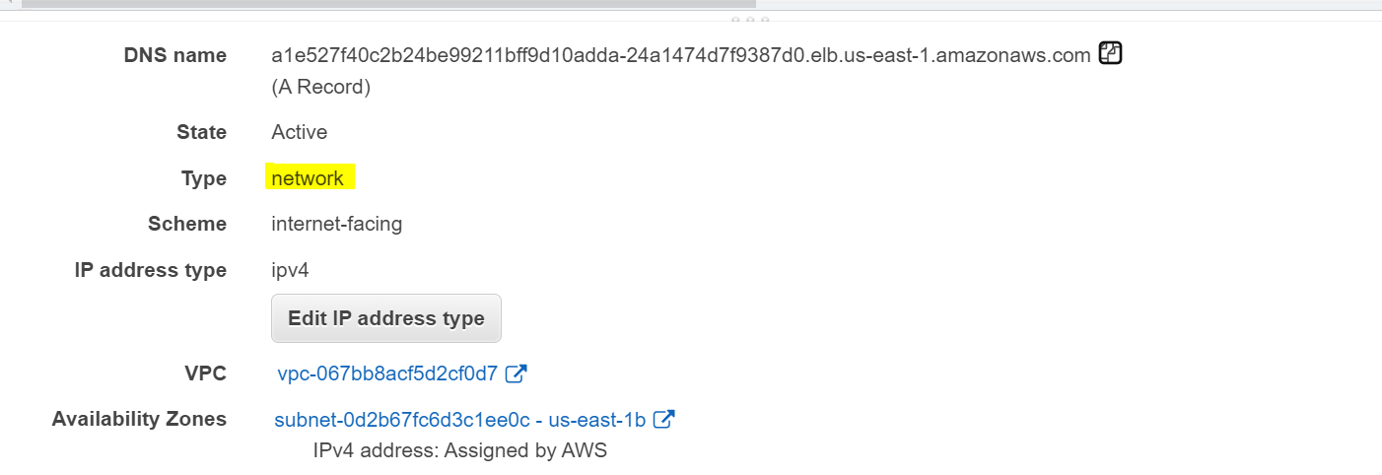

but there is no annotations related to NLB, checked the annotations for NLB.

**service.beta.kubernetes.io/aws-load-balancer-backend-protocol: tcp**

**service.beta.kubernetes.io/aws-load-balancer-cross-zone-load-balancing-enabled: "true"**

**service.beta.kubernetes.io/aws-load-balancer-type: nlb**

Added above 3 annotations in ingress-controller like this,

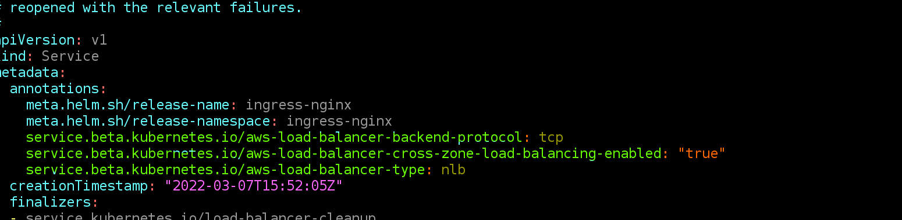

Now checked the **– hostname**: in ingress controller, now it showing Active ALB value.



Ingress address also mapped to same value.



Now tried to hit the endpoints in sandbox-ingress it is working fine.

It is for keycloak.

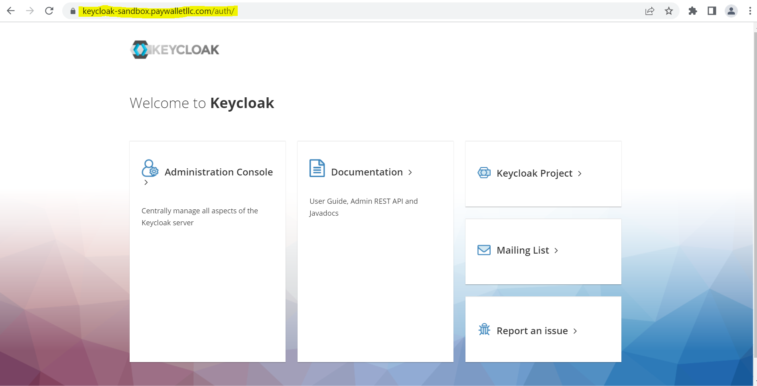

It is for kong.

